-- Sales_Order_Detail

CREATE TABLE Sales_Order_Detail(

SalesID CHAR(10) NOT NULL,

ItemID CHAR(10) NOT NULL,

ItemName VARCHAR(50),

Unit VARCHAR(10),

Quantity INT,

Price DECIMAL(10, 2),

Amount DECIMAL(12, 2)

);

-- Insert values into table of “Sales_Order_Detail”

insert into Sales_Order_Detail (SalesID, ItemID, ItemName, Unit, Quantity, Price, Amount ) values (1, 1, 'X-Box', 1, 5, 100, 20);

insert into Sales_Order_Detail (SalesID, ItemID, ItemName, Unit, Quantity, Price, Amount ) values (2, 2, 'KK-Box', 2, 2, 300, 10);

insert into Sales_Order_Detail (SalesID, ItemID, ItemName, Unit, Quantity, Price, Amount ) values (3, 3, 'G-Box', 3, 6, 500, 5);

-- Query all rows of column from Sales_Order_Detail and present

Select * from Sales_Order_Detail;

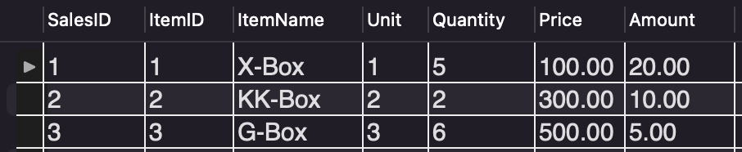

-- VIEW

Create view v_Sales_Order_Detail AS select SalesID, ItemName, Quantity, Price from Sales_Order_Detail;

-- Query all rows of column from v_Sales_Order_Detail and present

Select * from v_Sales_Order_Detail;

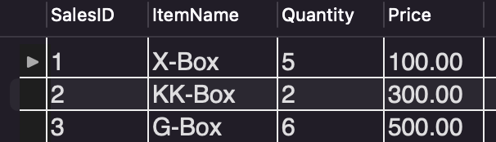

-- Update the row of column from v_Sales_Order_Detail and present

Update v_Sales_Order_Detail set SalesID = 100 where SalesID = 2;

select * from v_Sales_Order_Detail;

-- Query all rows of column from Sales_Order_Detail and present

-- You will see the original table of value itself, being updated

select * from Sales_Order_Detail;

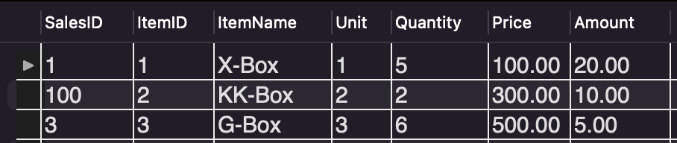

-- A kindly Reminder:

/*

The rows of column that developer does query the VIEW table (i.e., v_Sales_Order_Detail), is completely from the original data of Table: Sales_Order_Detail.

Developer can add, query, update, and delete in the VIEW table.

DB Engineer creates VIEW table, is likely to limit the accessed privilege of column(s) and only present the columns in need for developer

*/